WEEK 4
SESSION1: Constraint-Driven Solution Design

TASK1:Determine if string halves are alike
PROGRAM:

class Solution {
public boolean halvesAreAlike(String s) {
int count = 0;
int mid = s.length() / 2;
for (int i = 0; i < mid; i++) {
if ("aeiouAEIOU".indexOf(s.charAt(i)) != -1)
count++;
}
for (int i = mid; i < s.length(); i++) {
if ("aeiouAEIOU".indexOf(s.charAt(i)) != -1)
count--;
}
return count == 0;
}
}

OUTPUT:
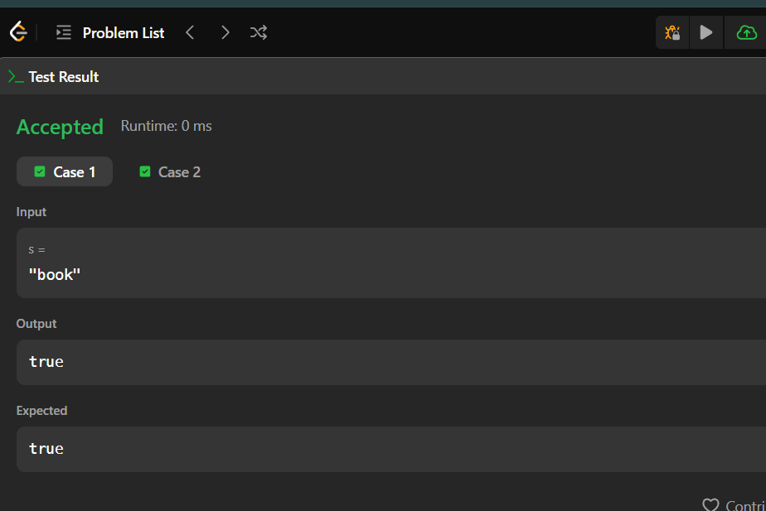
TASK2: CodeChef problem
PROGRAM:

import java.util.*;
class Main {
public static void main(String[] args) {
Scanner sc = new Scanner(System.in);
int T = sc.nextInt();
while (T-- > 0) {
String s = sc.next();
int n = s.length();
int[] freq = new int[26];

for (int i = 0; i < n / 2; i++) {
freq[s.charAt(i) - 'a']++;
freq[s.charAt(n - 1 - i) - 'a']--;
}
boolean lapindrome = true;
for (int x : freq) {
if (x != 0) {
lapindrome = false;
break;
}
}
System.out.println(lapindrome ? "YES" : "NO");
}
sc.close();
}
}
OUTPUT:
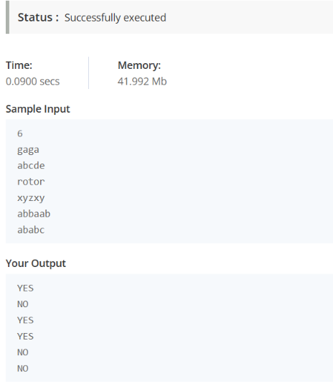

SESSION 2: Competitive Problem Patterns

TASK3: Compare the Triplets
PROGRAM:

import java.io.*;
import java.util.*;
public class Solution {
public static List<Integer> compareTriplets(List<Integer> a, List<Integer> b) {
int alice = 0;
int bob = 0;
for (int i = 0; i < 3; i++) {
if (a.get(i) > b.get(i)) {
alice++;
} else if (a.get(i) < b.get(i)) {
bob++;
}
}
return Arrays.asList(alice, bob);
}
public static void main(String[] args) throws IOException {
BufferedReader bufferedReader = new BufferedReader(new InputStreamReader(System.in));
BufferedWriter bufferedWriter = new BufferedWriter(new FileWriter(System.getenv("OUTPUT_PATH")));
String[] aTemp = bufferedReader.readLine().trim().split(" ");
List<Integer> a = new ArrayList<>();
for (String s : aTemp) {
a.add(Integer.parseInt(s));
}
String[] bTemp = bufferedReader.readLine().trim().split(" ");
List<Integer> b = new ArrayList<>();
for (String s : bTemp) {
b.add(Integer.parseInt(s));
}
List<Integer> result = compareTriplets(a, b);
for (int i = 0; i < result.size(); i++) {
bufferedWriter.write(String.valueOf(result.get(i)));
if (i != result.size() - 1) {
bufferedWriter.write(" ");
}
}
bufferedWriter.newLine();
bufferedReader.close();
bufferedWriter.close();
}
}
OUTPUT:
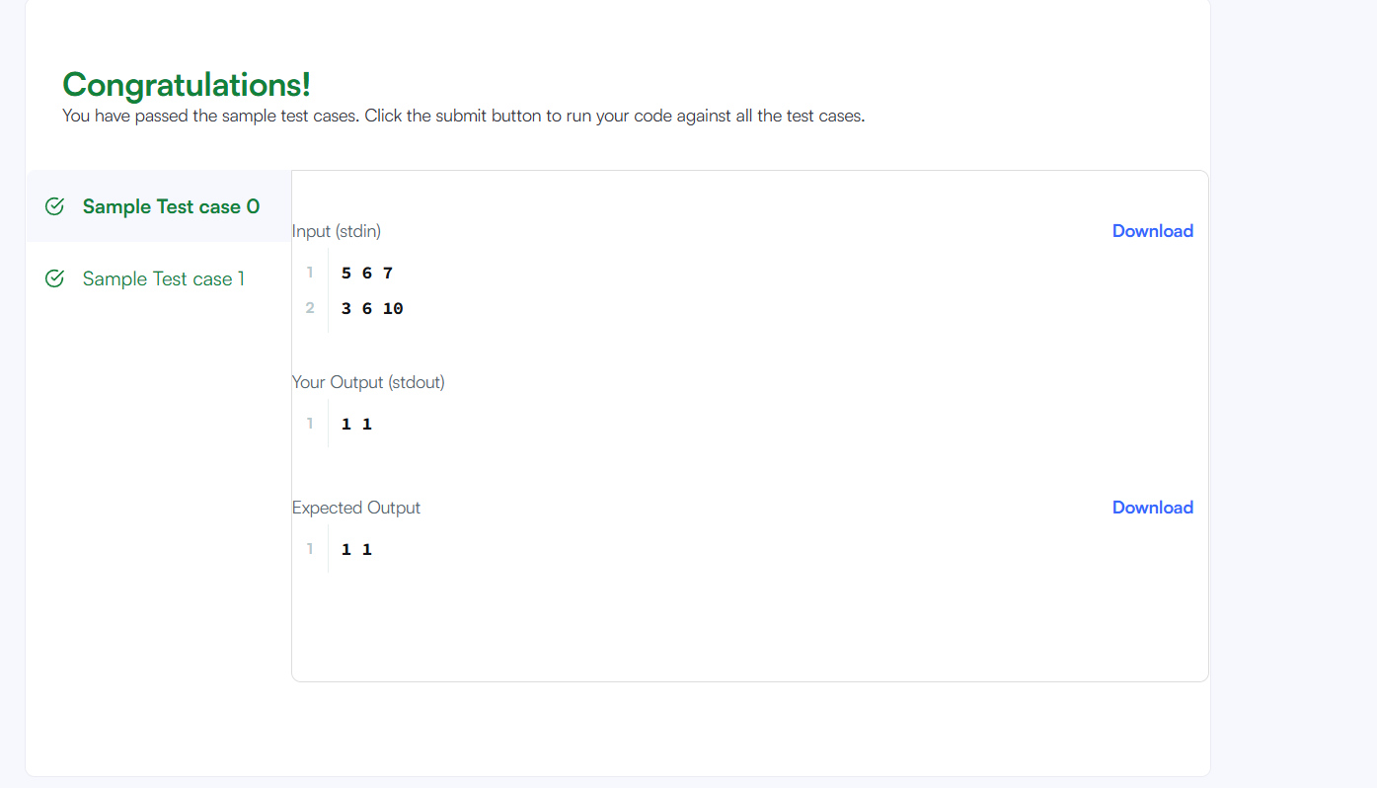

TASK4: contains duplicate

PROGRAM:
class Solution {
public boolean containsDuplicate(int[] nums) {
HashSet<Integer> set = new HashSet<>();
for (int n : nums) {
if (!set.add(n))
return true;
}
return false;
}
}
OUTPUT:
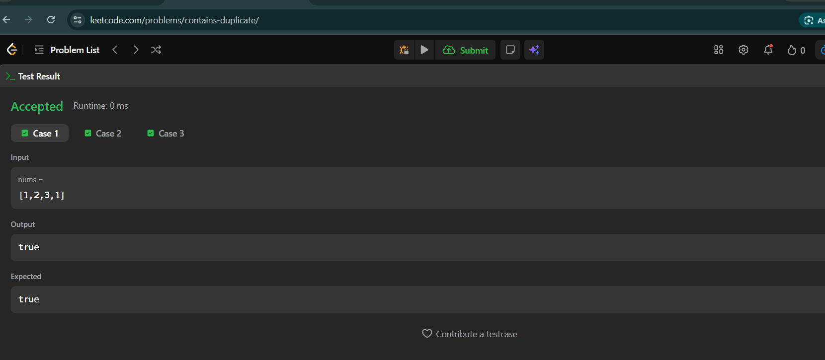
SESSION3: Writing Efficient Code
TASK5:TIME CONVERSTION

PROGRAM:
import java.io.*;
import java.util.*;
public class Solution {
public static String timeConversion(String s) {
String period = s.substring(8, 10);
int hour = Integer.parseInt(s.substring(0, 2));
if (period.equals("AM")) {
if (hour == 12) {
hour = 0;
}
} else {
if (hour != 12) {
hour += 12;
}
}
return String.format("%02d", hour) + s.substring(2, 8);
}
public static void main(String[] args) throws IOException {
BufferedReader bufferedReader =
new BufferedReader(new InputStreamReader(System.in));
BufferedWriter bufferedWriter =
new BufferedWriter(new FileWriter(System.getenv("OUTPUT_PATH")));
String s = bufferedReader.readLine();
String result = timeConversion(s);
bufferedWriter.write(result);
bufferedWriter.newLine();
bufferedReader.close();
bufferedWriter.close();
}
}
OUTPUT:
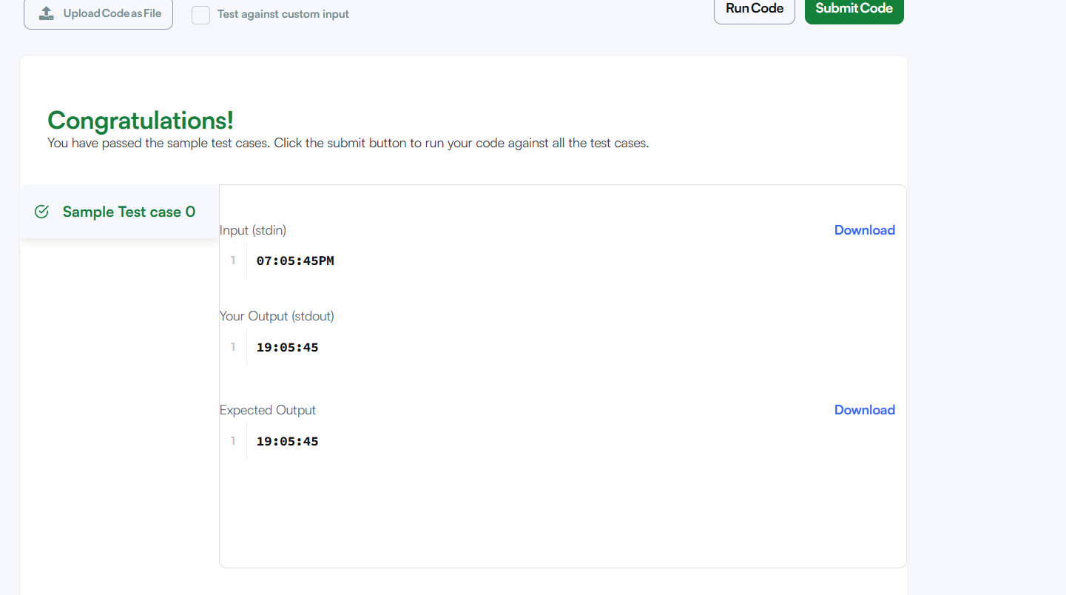
TASK6: MOVE ZEROS

PROGRAM:
class Solution {
public void moveZeroes(int[] nums) {
int j = 0;
for (int i = 0; i < nums.length; i++) {
if (nums[i] != 0) {
int temp = nums[i];
nums[i] = nums[j];
nums[j] = temp;
j++;
}
}
}
}
OUTPUT:
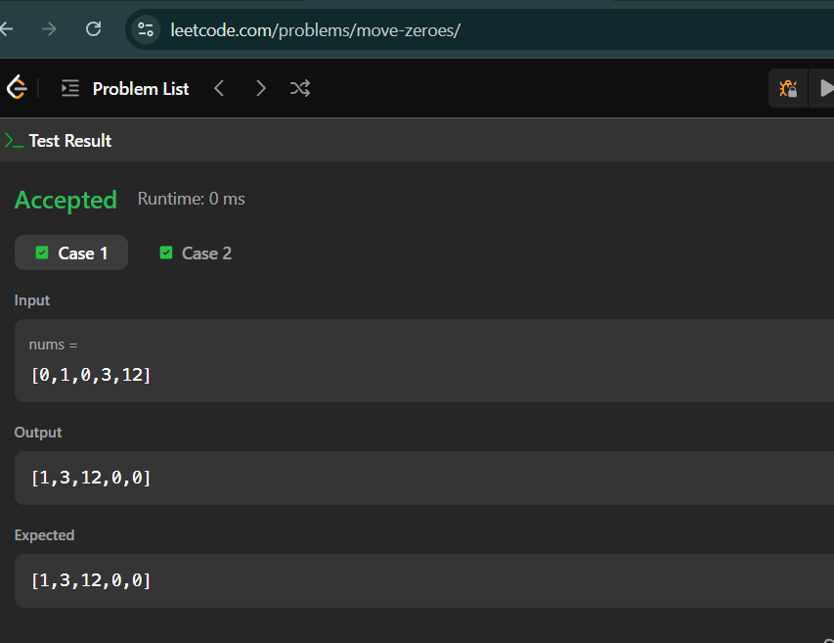
SESSION 4: Matrix Basics
TASK7: DIAGONOL DIFFERENCE

PROGRAM:
import java.io.*;
import java.util.*;
public class Solution {
public static int diagonalDifference(List<List<Integer>> arr) {
int n = arr.size();
int primary = 0;
int secondary = 0;
for (int i = 0; i < n; i++) {
primary += arr.get(i).get(i);
secondary += arr.get(i).get(n - 1 - i);
}
return Math.abs(primary - secondary);
}
public static void main(String[] args) throws IOException {
BufferedReader bufferedReader =
new BufferedReader(new InputStreamReader(System.in));
BufferedWriter bufferedWriter =
new BufferedWriter(new FileWriter(System.getenv("OUTPUT_PATH")));
int n = Integer.parseInt(bufferedReader.readLine().trim());
List<List<Integer>> arr = new ArrayList<>();
for (int i = 0; i < n; i++) {
String[] row = bufferedReader.readLine().trim().split(" ");
List<Integer> list = new ArrayList<>();
for (String value : row) {
list.add(Integer.parseInt(value));
}
arr.add(list);
}
int result = diagonalDifference(arr);
bufferedWriter.write(String.valueOf(result));
bufferedWriter.newLine();
bufferedReader.close();
bufferedWriter.close();
}
}
OUTPUT:
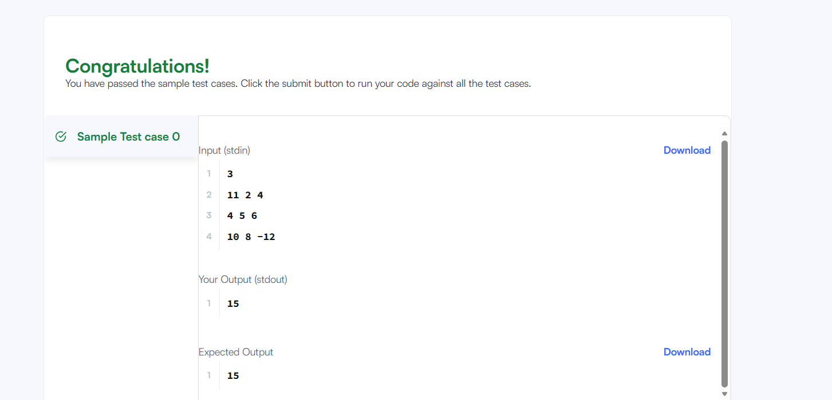

TASK 8: transpose matrix

PROGRAM:
class Solution {
public int[][] transpose(int[][] matrix) {
int rows = matrix.length;
int cols = matrix[0].length;
int[][] result = new int[cols][rows];
for (int i = 0; i < rows; i++) {
for (int j = 0; j < cols; j++) {
result[j][i] = matrix[i][j];
}
}
return result;
}
}
OUTPUT:
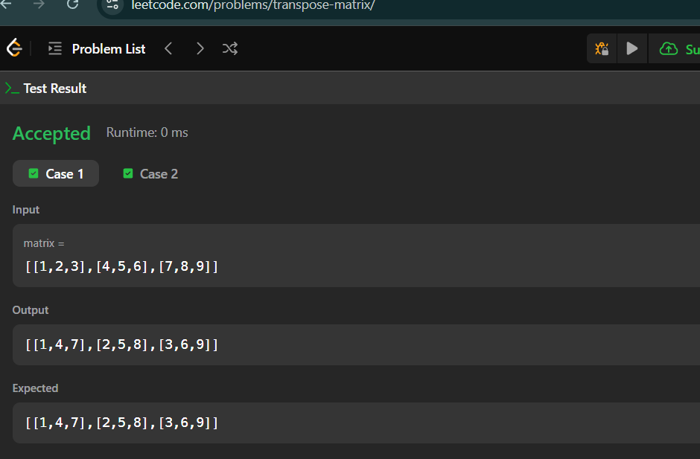
SESSION 5: Strassen’s Matrix Multiplication
TASK9:MATRIC BLOCK SUM

PROGRAM:
class Solution {
public int[][] matrixBlockSum(int[][] mat, int k) {
int m = mat.length;
int n = mat[0].length;
int[][] answer = new int[m][n];
for (int i = 0; i < m; i++) {
for (int j = 0; j < n; j++) {
int sum = 0;
int startRow = Math.max(0, i - k);
int endRow = Math.min(m - 1, i + k);
int startCol = Math.max(0, j - k);
int endCol = Math.min(n - 1, j + k);
for (int r = startRow; r <= endRow; r++) {
for (int c = startCol; c <= endCol; c++) {
sum += mat[r][c];
}
}
answer[i][j] = sum;
}
}
return answer;
}
}
OUTPUT:
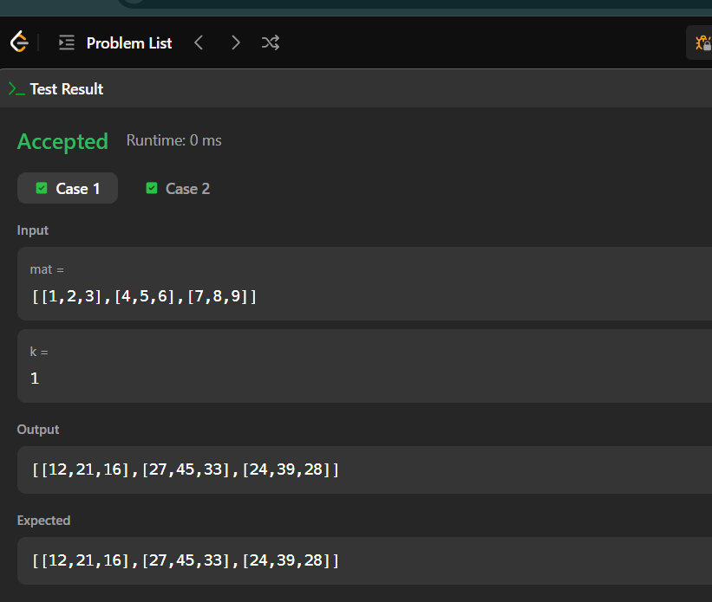
TASK 10:matrix rotation

PROGRAM:
import java.io.*;
import java.util.*;

public class Solution {

public static void matrixRotation(List<List<Integer>> matrix, int r) {
int m = matrix.size();
int n = matrix.get(0).size();

int[][] result = new int[m][n];

for (int layer = 0; layer < Math.min(m, n) / 2; layer++) {

List<Integer> values = new ArrayList<>();

// Top row
for (int j = layer; j < n - layer; j++) {
values.add(matrix.get(layer).get(j));
}

// Right column
for (int i = layer + 1; i < m - layer; i++) {
values.add(matrix.get(i).get(n - layer - 1));
}

// Bottom row
for (int j = n - layer - 2; j >= layer; j--) {
values.add(matrix.get(m - layer - 1).get(j));
}

// Left column
for (int i = m - layer - 2; i > layer; i--) {
values.add(matrix.get(i).get(layer));
}

int size = values.size();
int rotation = r % size;

// Put rotated values back
int index = rotation;

// Top row
for (int j = layer; j < n - layer; j++) {
result[layer][j] = values.get(index % size);
index++;
}

// Right column
for (int i = layer + 1; i < m - layer; i++) {
result[i][n - layer - 1] = values.get(index % size);
index++;
}

// Bottom row
for (int j = n - layer - 2; j >= layer; j--) {
result[m - layer - 1][j] = values.get(index % size);
index++;
}

// Left column
for (int i = m - layer - 2; i > layer; i--) {
result[i][layer] = values.get(index % size);
index++;
}
}

for (int i = 0; i < m; i++) {
for (int j = 0; j < n; j++) {
System.out.print(result[i][j] + " ");
}
System.out.println();
}
}

public static void main(String[] args) throws IOException {

BufferedReader bufferedReader =
new BufferedReader(new InputStreamReader(System.in));

String[] firstLine = bufferedReader.readLine().trim().split(" ");

int m = Integer.parseInt(firstLine[0]);
int n = Integer.parseInt(firstLine[1]);
int r = Integer.parseInt(firstLine[2]);

List<List<Integer>> matrix = new ArrayList<>();

for (int i = 0; i < m; i++) {
String[] row = bufferedReader.readLine().trim().split(" ");

List<Integer> list = new ArrayList<>();

for (String value : row) {
list.add(Integer.parseInt(value));
}

matrix.add(list);
}

matrixRotation(matrix, r);

bufferedReader.close();
}
}
OUTPUT:
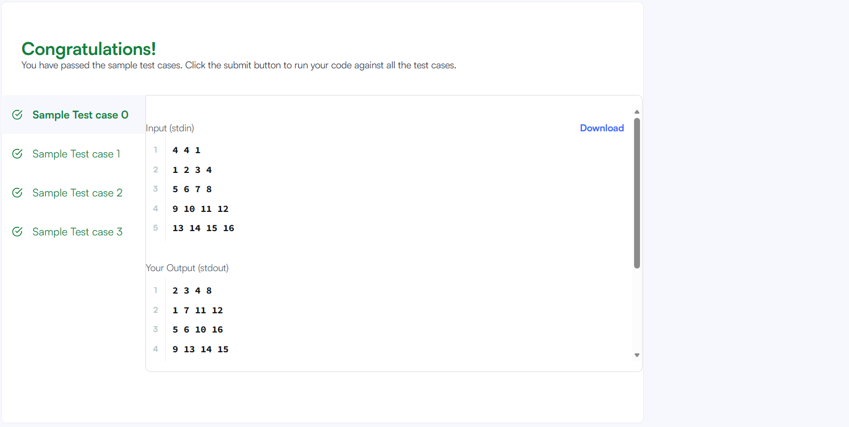

RESULT: Thus the week 4 tasks and session has completed successfully.

